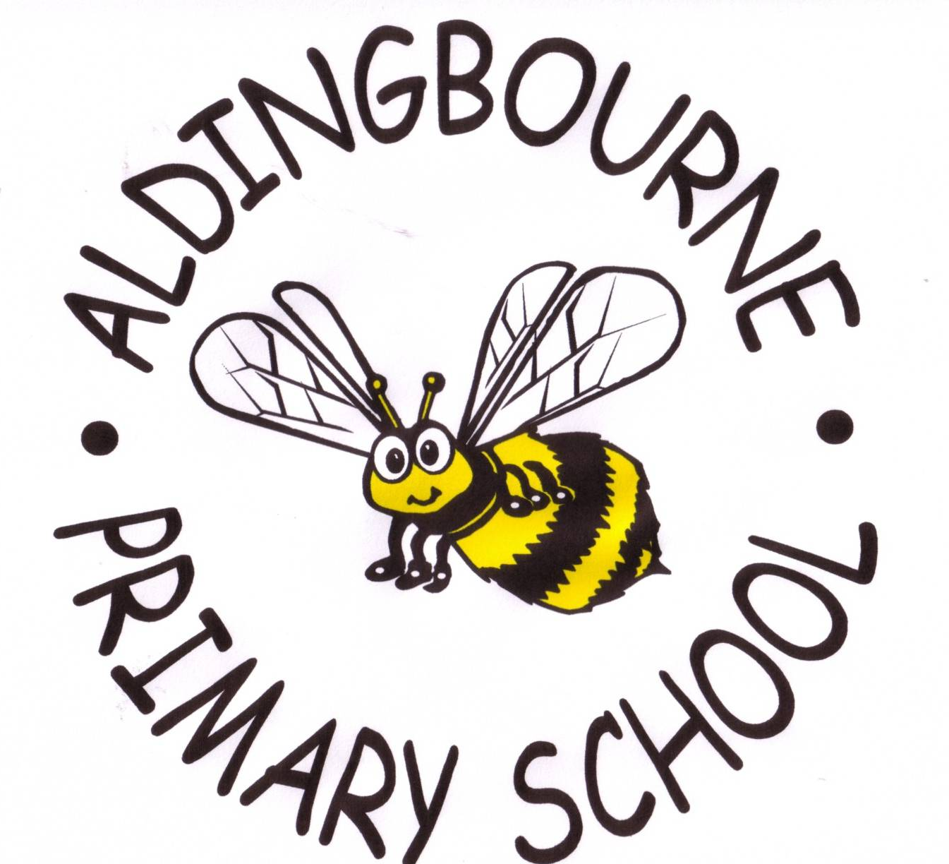

Learning to bee the best that we can bee!
Promoting British Values
In 2011, the government defined British Values as
DEMOCRACY
THE RULE OF LAW,
INDIVIDUAL LIBERTY
MUTUAL RESPECT and TOLERANCE of DIFFERENT FAITHS/ BELIEFS.
At this school, we promote these values through our VISION, our SCHOOL VALUES and the WIDER CURRICULUM.

BRITISH  VALUES | HOW DO WE PROMOTE IT?
Democracy | - The MCM (school council) is made up of pupils from KS1 and KS2 voted by their peers  - The MCM has a suggestion board in the school hall. Children can write suggestions on laminated busy bees and the MCM will respond to their suggestions / questions  - The MCM meet weekly  - Ideas are discussed in class and fed back to the School Council, ensuring that the “pupil voice” is heard  - Y6 House Sports captains are elected annually by the pupils  - Pupil voice is also evident in lessons, as children respond to adults’ marking  - The concept of democracy/ freedom of choice is taught in PSHCE lessons and assemblies  - All pupils can volunteer for responsibilities within their own classroom such as pencil monitor, cloakroom monitor etc. Year 6 pupils can volunteer for responsibilities around the school such as Playground Leaders, librarians etc  - Parents are asked to complete a school survey every two years, eliciting their views on aspects of the school’s performance  - The Head holds termly staff chats to discuss aspects of school life.  - The Governors hold an annual meeting for parents to discuss aspects of school life
The Rule of Law | - We have high expectations of pupil behaviour and this is reflected in our Behaviour policy  - Assemblies at the start of every term focus on the schools ‘Golden Rules’ and the consequences / impact of good and bad behaviour  - Each teacher discusses class rules with the pupils at the start of each academic year  - The Home/School Agreement sets out principles and roles of the school, pupil and family  - Good behaviour/ attitudes are rewarded with adult praise, house points, outstanding busy bees, postcards, and whale awards.  - Poor behaviour is consistently and age-appropriately addressed  - Friday assembly includes public recognition of good behaviour/ attitude/ work is given in front of the whole school  - Knowing right from wrong/ making good choices/ developing a sense of fairness is taught in assemblies and PSHCE lessons. This includes a visit to year 6 by magistrates from the local courts.
Individual Liberty | - Pupils at our school can make lots of choices – who to play with, what to play, how to challenge themselves in class  - Pupils are also taught that with choice, comes responsibility  - We encourage pupils to think about what they would like to do in the future (to raise aspiration)  - Pupils have a good range of clubs to choose from  - Assemblies that focus on “Good To Be Me” reinforces the message of individual liberty  - Individual liberty is encouraged within a safe school environment. Pupils are involved in risk assessment and learn about e-safety, anti-bullying and keeping themselves safe in and out of school
Mutual Respect | - Respect is at the heart of our school vision and values  - Children are reminded to respect each other in PSHCE lessons, on the playground and in assemblies  - Assemblies that focus on “Getting On and Falling Out” explore the issue of mutual respect  - Mutual respect is encouraged as pupils work in a variety of groupings throughout the week, when co-operation and collaboration are expected behaviours  - Staff model mutual respect by respecting children, parents, Governors and most importantly each other  - Our expectations for mutual respect are inherent within our Behaviour and Equality policies
Tolerance of Different Faiths & Beliefs | - At this school we prefer to compare/ contrast and celebrate different faiths and beliefs rather than merely “tolerate” them  - In RE pupils celebrate festivals such as Chinese New Year and Diwali, as well as the traditional Christian festivals (Harvest, Christmas, Easter)  - Our annual Book Week often has a multi-cultural theme  - Children from a range of nationalities and faith groups are encouraged to talk about their experiences in class  - Assemblies focus on tolerance of others  - RE lessons focus on different religions, visits to the local mosque, synagogue and local churches allow children to understand and celebrate different faiths and beliefs

As well as actively promoting British Values, we also actively challenge views that are clearly opposed to British Values, including more “extremist” views.

